Team Collaboration Model

Working Together for Maximum Impact

Develop one set of content for each team involved in the collaboration:

|  |
| --- |
| <Team Name > Core Responsibilities: |
|  |
|  |
|  |
|  |
|  |

| < Team Name > Collaboration Plan | | |
| --- | --- | --- |
| Should provide to: | Needs from: | Should do together with: |
| **Role A**   * X * X * X * X | **Role A**   * X * X * X * X | **Role A**   * X * X * X * X |
| **Role B**   * X * X * X * X | **Role B**   * X * X * X * X | **Role B**   * X * X * X * X |
| **Role C**   * X * X * X * X | **Role C**   * X * X * X * X | **Role C**   * X * X * X * X |
| **Role D**   * X * X * X * X | **Role D**   * X * X * X * X | **Role D**   * X * X * X * X |

Collaboration Workshop Suggestions

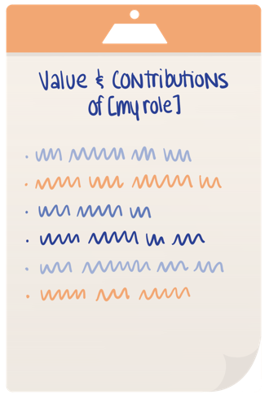

* If the team can meet in person, set up flip charts around the room. At the top of each flip chart, put the name of a role that’s on the team, one role per flip chart. If the team is meeting virtually, set up a virtual whiteboard with appropriate spaces for each role.
* Have each person go to the chart or space for their role and make a list of the core contributions and value that their role provides to the team. If there’s more than one person playing a role, they should brainstorm this list together.
* Once each role has their list of added-value complete, everyone should rotate! Each individual or group (by role) should move over to the next chart or space to read the list of another role’s contributions to appreciate what they have to offer.
* 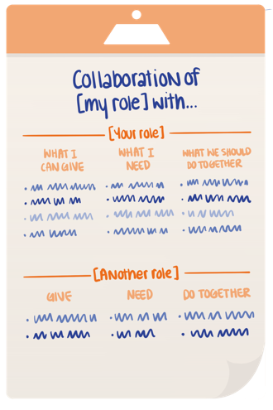Considering what you know of your own role, create a new list using the following questions:
  + How can you support and enable the other role’s valuable contributions?
  + How can they support and enable your role?
  + How will you collaborate?
* Each role should capture their collaborative opportunities with the other roles, one chart or space at a time. Go around the room and consider what’s in front of you, then:
  + Document what you can give to the other role that will be helpful for them
  + Identify what you need to get from that role to do your own job effectively
  + Capture what you think you should be doing together for best effect toward the outcome
* When each role has gone through each chart or space and contributed their thinking, they will arrive back at their own. Review!

Does anything surprise you? Did another role offer contributions that weren’t expected or known? Are there things that others would give to or need from your role, which you weren’t aware of? Do you find new opportunities for collaboration between roles?

For more details, please read our blog post: [Don't Drop The Ball! Define Your Team's Collaboration Model](https://b2ttraining.com/dont-drop-the-ball-define-your-teams-collaboration-model/).