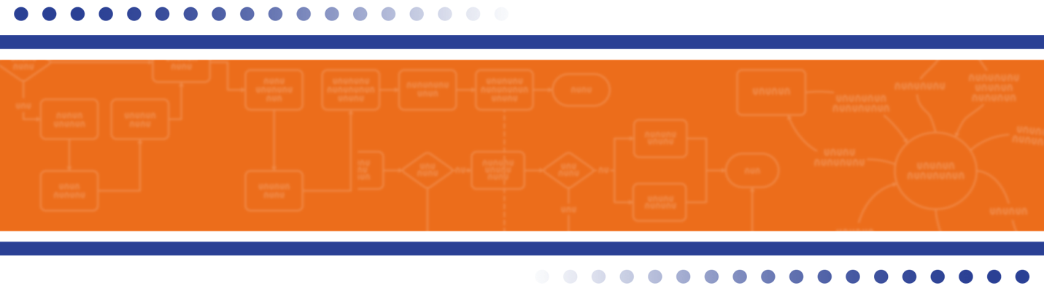

Business Case
Sample Format

<<Project Name>>

<<Date>>

Submitted by:
<<Author Name>>
<<Title>>
<<Date>>

Cover Letter Sample

Date: <<Month Day, Year>>

To: <<Distribution List>>

<<Body>>

I am enclosing a copy of the Business Case for <<Project Name>>. This report is in response to a request from <<Requestor Name>> to make a recommendation for <<brief description of project>>. In the report I propose that we <<brief description of recommendation>>.

Please review this report and let me know if you have additional questions. I am available to meet with you to discuss the recommendations at your convenience.

<<Author>>
<<Title>>

Enclosure

Business Case for
<<Project Name>>
Table of Contents

Executive Summary 1
Overview of Recommendation 1
Mission Statement and Business Value 1
Consequences of Inaction 1
Summary of Analysis Approach Used 1
Rationale for Recommendation 2
Description of the Alternatives Considered 2
Alternative 1 2
Alternative 2 2
Alternative N 2
Cost/Benefit Comparison 3
Implementation Costs 3
Ongoing/Operating Costs 3
Benefits (per year) 3
Details for Recommended Alternative 4
Costs and Benefits of Recommended Alternative 4
Ongoing costs 4
Implementation Costs 4
Benefits 4
Summary of Ongoing Benefits 4
Risks, Assumptions, Constraints and Dependencies 5
Description of Analysis Approach Used 5
Preliminary Implementation Plan 5
Additional Documentation 6

Executive Summary

Overview of Recommendation
I recommend <<one to two paragraph description of the recommendation>>.
I am making this recommendation because <<describe major benefits here>>.
The cost of accepting this recommendation is <<describe major costs here>>.
The overall benefit to be gained by accepting this recommendation is <<describe major benefits here>>.

Mission Statement and Business Value
<<Describe the mission of the project – why it is being done.>>
Business Objectives
<<Describe the value of the proposal to the business. This may be done with business objectives, OKRs, and/or KPIs..>>
- <<Specific Objective 1>>
- <<Specific Objective 2>>
- <<Specific Objective 3>>

Consequences of Inaction
<<Detail the consequences that will result if no action is taken to address the problem or opportunity.>>

Summary of Analysis Approach Used
<<Briefly describe the analysis approach that was used to develop the business case.>>

Rationale for Recommendation

Description of the Alternatives Considered

<<Number>> alternatives were considered:
- <<Alternative 1 – list the recommended alternative here>>
- <<Alternative 2>>
- <<Alternative N>>

Alternative 1
<<Description of this alternative>>

Alternative 2
<<Description of this alternative>>

Alternative N
<<Description of this alternative>>

Cost/Benefit Comparison

Implementation Costs
Cost | Alternative 1 | Alternative 2 | Alternative 3 | Notes
Personnel | $9999 | $9999 | $9999
Equipment | $9999 | $9999 | $9999
Set up fees | $9999 | $9999 | $9999
Administration | $9999 | $9999 | $9999
Total | $9999 | $9999 | $9999

Ongoing/Operating Costs
Cost Per Year | Alternative 1 | Alternative 2 | Alternative 3 | Notes
Personnel | $9999 | $9999 | $9999
Equipment | $9999 | $9999 | $9999
Set up fees | $9999 | $9999 | $9999
Administration | $9999 | $9999 | $9999
Total | $9999 | $9999 | $9999

Benefits (per year)
Cost | Alternative 1 | Alternative 2 | Alternative 3 | Notes
Personnel | $9999 | $9999 | $9999
Equipment | $9999 | $9999 | $9999
Set up fees | $9999 | $9999 | $9999
Administration | $9999 | $9999 | $9999
Total | $9999 | $9999 | $9999

Details for Recommended Alternative
<<Provide a more detailed description of the recommended alternative>>

Costs and Benefits of Recommended Alternative

Ongoing costs
<<Detail the costs that will be incurred on an ongoing basis once the recommendation is implemented.>>

Implementation Costs
<<Detail the costs that will be incurred to implement and transition to the recommended alternative.>>

Benefits
<<List the specific benefits that will accrue from the proposal, both tangible and intangible.>>
Tangible:

Intangible:

Summary of Ongoing Benefits

 | Year 1 | Year 2 | Year 3 | Year 4
Implementation costs | $9999 | $9999 | $9999 | $9999
Ongoing/operating costs | $9999 | $9999 | $9999 | $9999
Benefits | $9999 | $9999 | $9999 | $9999
Return on Investment | $9999 | $9999 | $9999 | $9999

Risks, Assumptions, Constraints and Dependencies
Risks
- <<Risk 1>>
- <<Risk 2>>
Assumptions
- <<Assumption 1>>
- <<Assumption 2>>

Constraints
- <<Constraint 1>>
- <<Constraint 2>>

Dependencies
- <<Dependency 1>>
- <<Dependency 2>>

Description of Analysis Approach Used
<<Provide a more detailed description of the analysis approach used to reach the recommendation.>>

Preliminary Implementation Plan
<<If an implementation approach or plan has been established, provide details here.>>

Additional Documentation
<<This section should be used to provide in-depth information on the recommended alternative. It may be helpful to build a table of contents for this section.>>

